NETWORK ARCHITECTURE 1

HOME WORK -2

SUBMITTED BY

JASWANTH KRISHNA AAVULA

16133295

1. Suppose within your Web browser you click on a link to obtain a web page. The IP address for the associated URL is cached in your local host, so a DNS look-up is not necessary to obtain the IP address. Further suppose that the Web page associated with the link references three very small objects on the same server. Let RTT0 denote the RTTs between the local host and one of the objects. Assuming zero transmission time of the object, how much time elapses from when the client clinks on the link until the client receives the full web page with

a. Nonpersistent HTTP?

b. Persistent HTTP?

Ans:

**Non Persistent HTTP without parallel connections:**

In nonpersistent HTTP a new TCP connection has to be established for each object. So the total time taken would be two round trip times.

Time taken to receive base file = 2RTT0

Time taken to receive each object = 2RTT0

Total number of objects = 3

Therefore time taken for 3 objects = 3(2RTT0) = 6RTT0

So total time taken = 6RTT0+2RTT0 = 8RTT0

**Non Persistent HTTP with parallel connections:**

In nonpersistent HTTP with parallel connections all the objects can be sent at time by establishing multiple TCP connections parallel. This would reduce the time taken for receiving objects.

Time taken to receive base file = 2RTT0

Time taken to receive all the objects in parallel = 2RTT0

Total time taken for 3 objects = 2RTT0+2RTT0 = 4RTT0

**Persistent HTTP without pipelining connections:**

In a persistent connection a TCP connection is setup first and the objects are sent through same TCP connection

Time taken to receive base file = 2RTT0

Time taken to receive each object = RTT0

Total number of objects = 3

Therefore time taken for all the three objects= 3RTT0

Therefore total time taken = 3RTT0 + 2RTT0 = 5RTT0

**Persistent HTTP with pipelining :**

In persistent HTTP with pipelining all the objects are received in a single Round trip Time by establishing parallel connections.

Time taken to receive base file= 2RTT0

Time taken to receive all the objects through pipelining = RTT0

Therefore total time taken = 2RTT0 + RTT0 = 3RTT0.

2. Describe in detail how to register domain names and IP address for your start-up Company (what companies to contact, how much is the fee, etc.).

Ans:

* The first step in registering a domain name is to check the availability of a domain name. Several web based tools are available for checking the availability of a domain name. Many of the registrars provide the service of domain name verification.
* Once the domain name is found to be available one has to contact domain registrars to register our domain name,
* The domain name registrar would register the static IP addresses and names of the servers in the relevant TLD server.
* There are many domain name registrars like Network solutions, Go daddy, eNom available. They collect nominal fee($5,$10,$40..).The domain name has to be renewed periodically.
* After completing these steps the domain name registered and a user from any part of the world can access the webpage by entering the website name.

3. What is meant by a handshaking protocol? What is/are an example(s) of handshaking protocol?

Ans: Hand shaking protocol is a method in which a connection is established between different end systems on a network. The connection establishment is done as follows. In the first step a request message is sent by the client for grabbing the attention of the server, then the server responds back by sending a response message that it is ready to service the request. Now the client requests for a data service and the server processes it.

Eg: Transmission Control Protocol (TCP)

Transport Layer Security (TLS)

4. Consider the Figure below, for which there is an institutional network connected to the Internet. Suppose that the average object size is 100,000 bits and that the average request rate from the institution’s browser to the origin servers is 4 requests per second. Also suppose that the amount of time it takes from when the router on the Internet side of the link forwards an HTTP request until it receives the responses in two seconds on average. Model the total average response time as the sum of the average access delay (that is, the delay from the Internet router to institution router) and the average Internet delay.

(a) Find the total average response time

(b) Now suppose a cache is installed in the institutional LAN. Suppose the hit rate is 0.4. Find the total response time.

Sol: a) length of the Object= L=100,000 bits

Average internet delay = 2 sec

R=1.5 Mbps

Transmission time over the access delay = L÷R

= 100000 ÷ (1.5*106)

= 1/15.Sec

There are 4 requests per second, therefore total traffic intensity= 4(1/15) = 4/15

So the average access delay = (1/15) ÷ (1- (4÷15))

=1÷11 sec.

The total average response time = Average access delay + Average internet delay

= (1/11) + (2)

= 23/11= 2.09 sec

b) The hit rate of the cache installed = 0.4

It means that 40 % of the requests generated are satisfied by the cache and the rest 60 % are serviced by the server.

So the delay for 40 % of the requests can be neglected because the delay from the cache is so small.

Therefore total delay= 0.6(2.09)= 1.254 Sec

**TELNET EXPERIMENTS:**

Part 1:

**GET:**

Response 1:

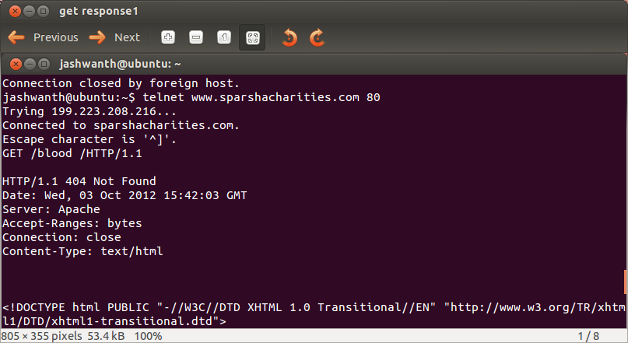

Response 2:

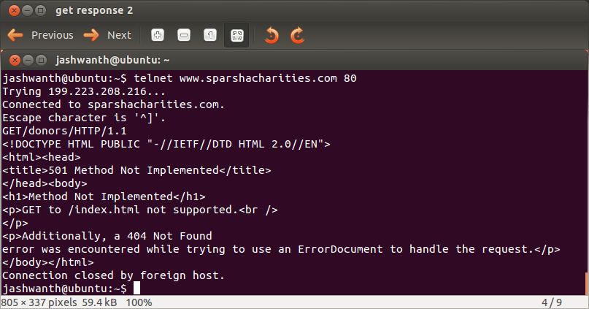

HEAD:

Response 1:

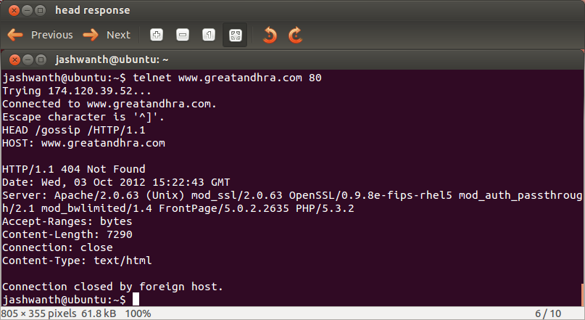

Response 2:

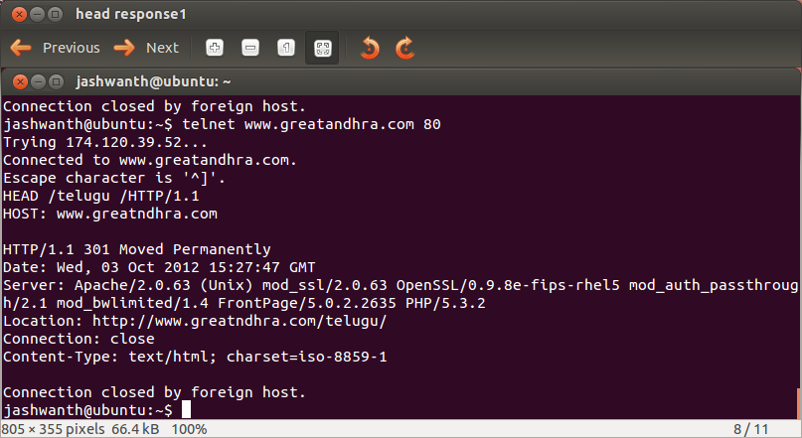

POST:

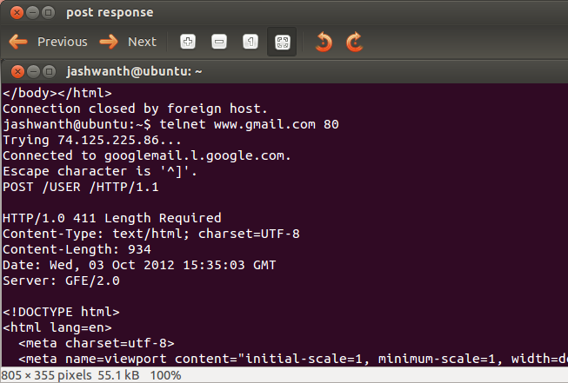

Response 2:

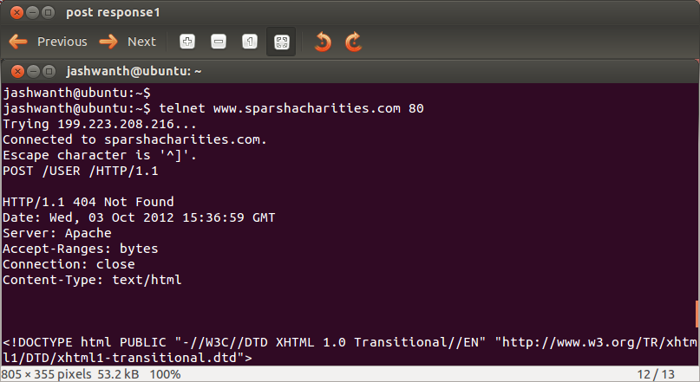

**WIRESHARK EXPERIMENT:**

Part 2_1:

1. Is your browser running HTTP version 1.0 or 1.1? What version of HTTP is the

server running?

Ans.

**BROWSER:**

My browser is running on HTTP version 1.1

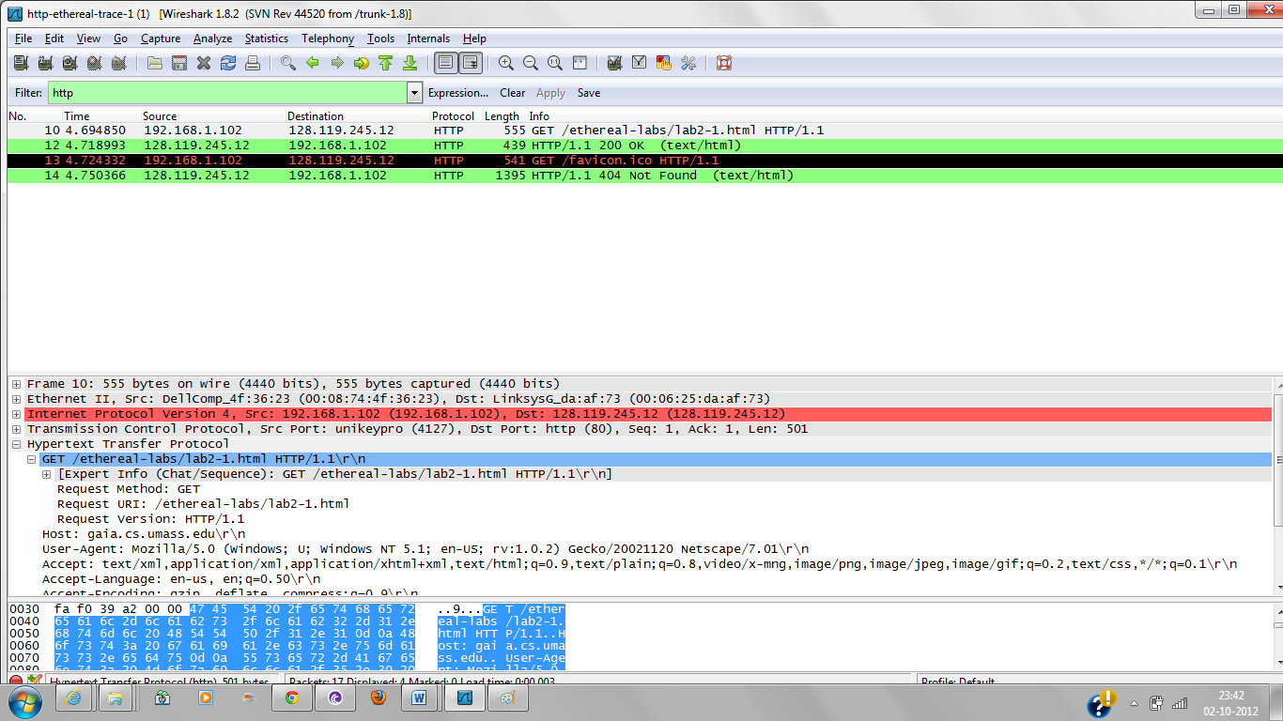

SERVER:

My server is running on HTTP version 1.1

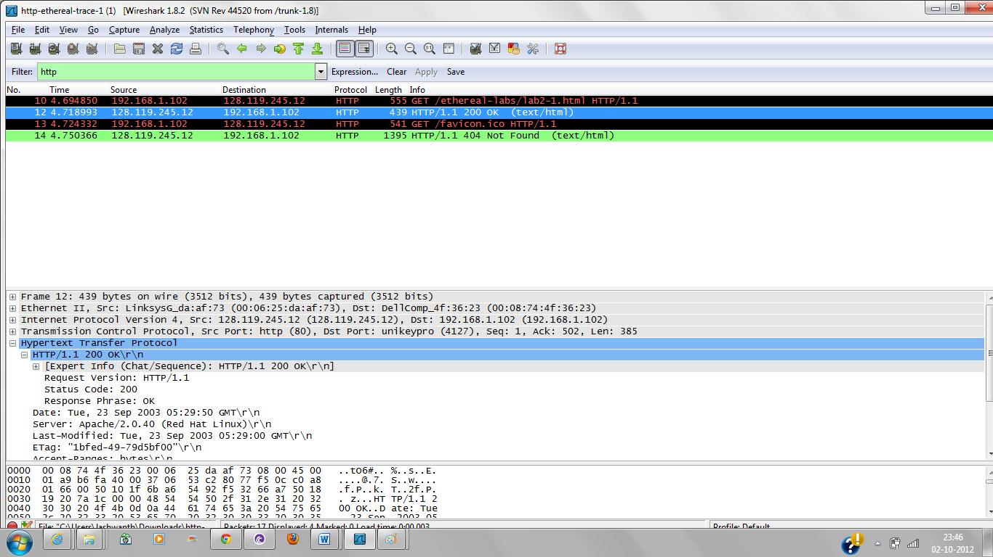

2. What languages (if any) does your browser indicate that it can accept to the server?

Ans. The languages the browser indicate that it can accept to the server are en-us, en;q=0.50

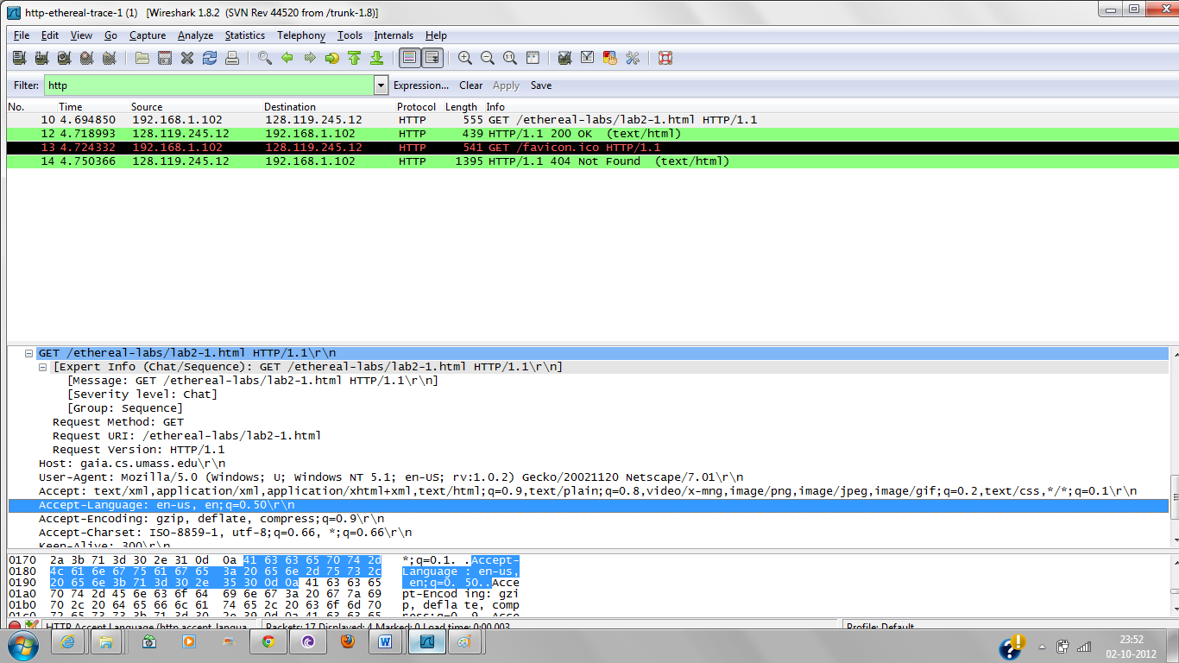

3. What is the IP address of your computer? Of the gaia.cs.umass.edu server?

Ans.

IP address of originating system is 192.168.1.102

IP address of gaia.cs.umass.edu destination is 128.119.245.12

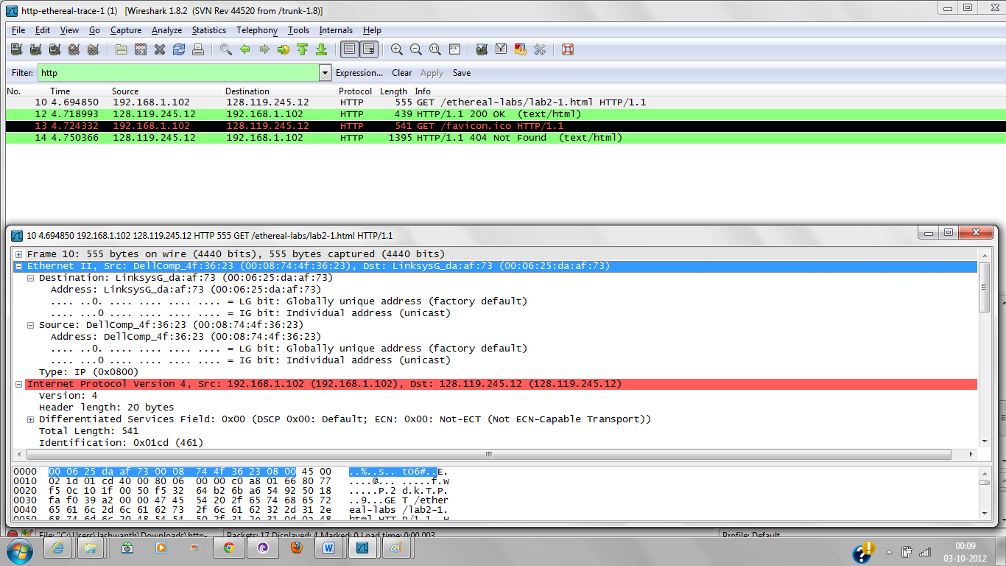

4. What is the status code returned from the server to your browser?

Ans. The status code returned is 200

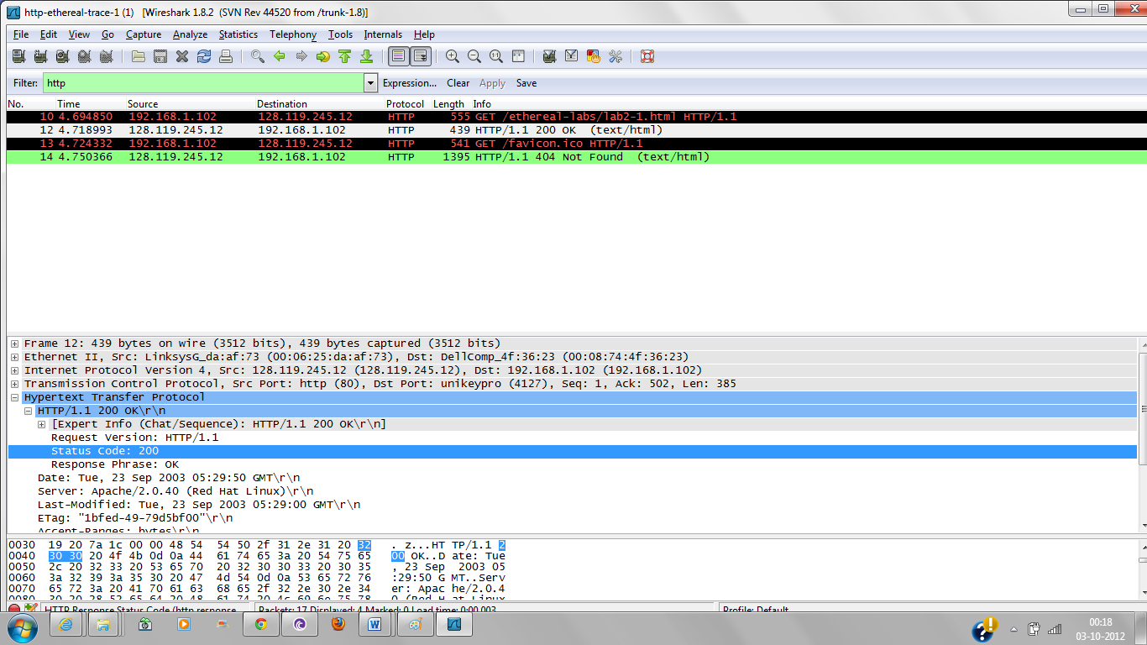

5. When was the HTML file that you are retrieving last modified at the server?

Ans. It was last modified on Tuesday , 23 September 2003 05:29:00 GMT

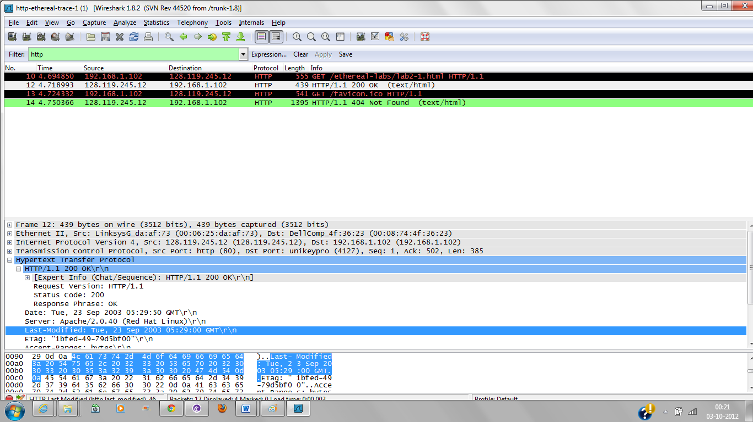

6. How many bytes of content are being returned to your browser?

Ans:

The content length returned by browser is 73 bytes.

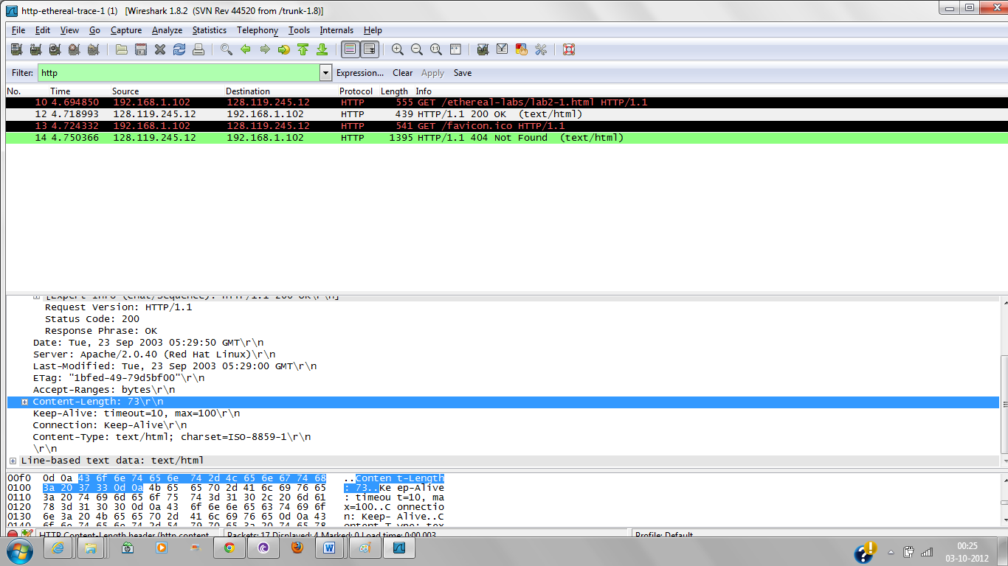

**Part 2-2: Retrieving Long Documents**

1.How many HTTP GET request messages were sent by your browser?

Ans: One Get request message was sent by the browser.

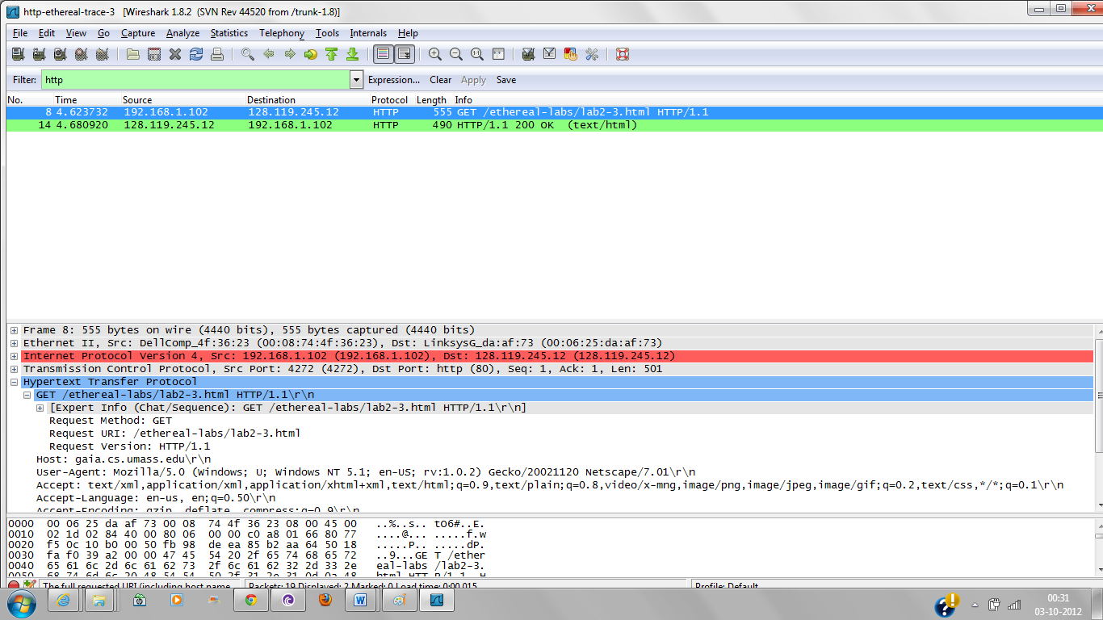

2. How many data-containing TCP segments were needed to carry the single HTTP response?

Ans: Four data containing TCP segments were needed to carry single HTTP response.

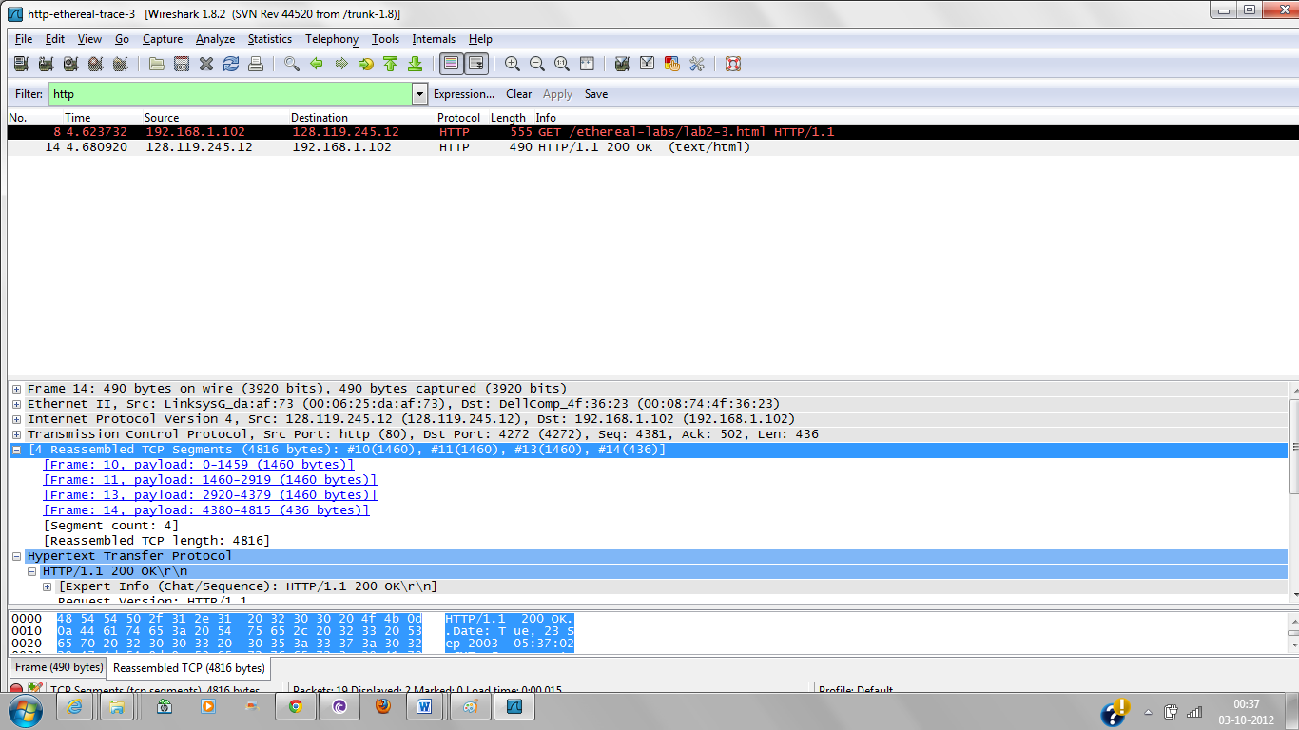

3. What is the status code and phrase associated with the response to the HTTP GET request?

Ans: Status Code: 200

Phrase :OK

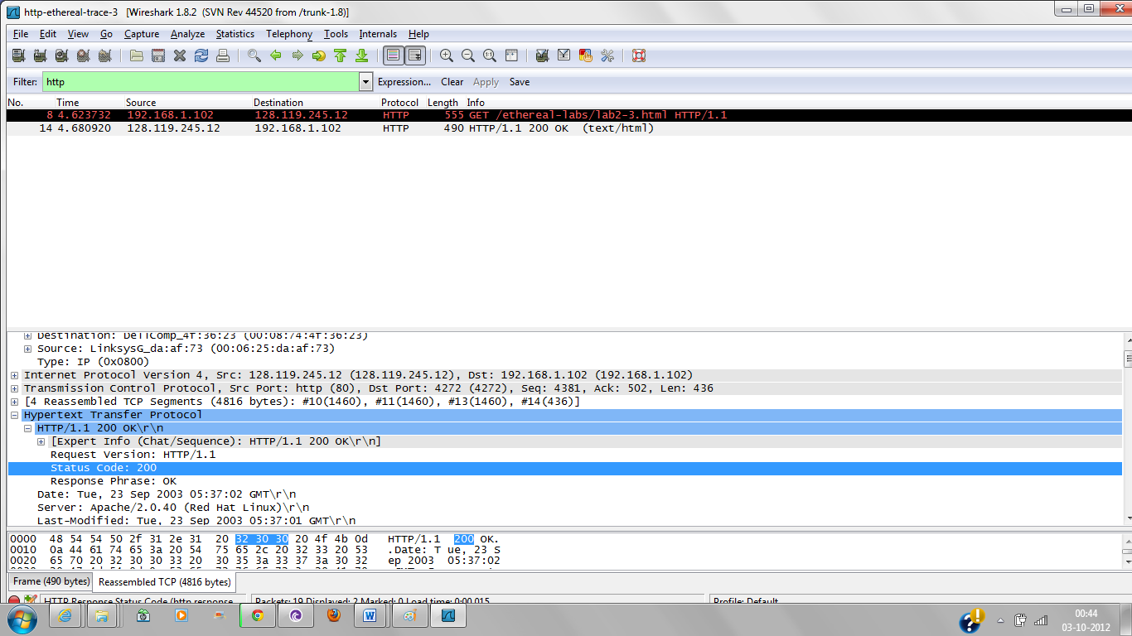

4. Are there any HTTP status lines in the transmitted data associated with a TCP induced “Continuation”?

Ans: No ,there are no status lines associated with TCP induced continuation.